Ideation Phase
Empathize & Discover

Date | 02 February 2026
Team ID | LTVIP2026TMIDS90283
Project Name | rising waters: a machine learning approach to flood prediction

Empathy Map Canvas:
An empathy map is a simple, easy-to-digest visual that captures knowledge about a user’s behaviours and attitudes.

It is a useful tool to helps teams better understand their users.
Creating an effective solution requires understanding the true problem and the person who is experiencing it. The exercise of creating the map helps participants consider things from the user’s perspective along with his or her goals and challenges.
Example:


Empathy Map Canvas - Rising waters: a machine learning approach to flood prediction
Target User: Local Citizen / Farmer / Disaster Management Officer

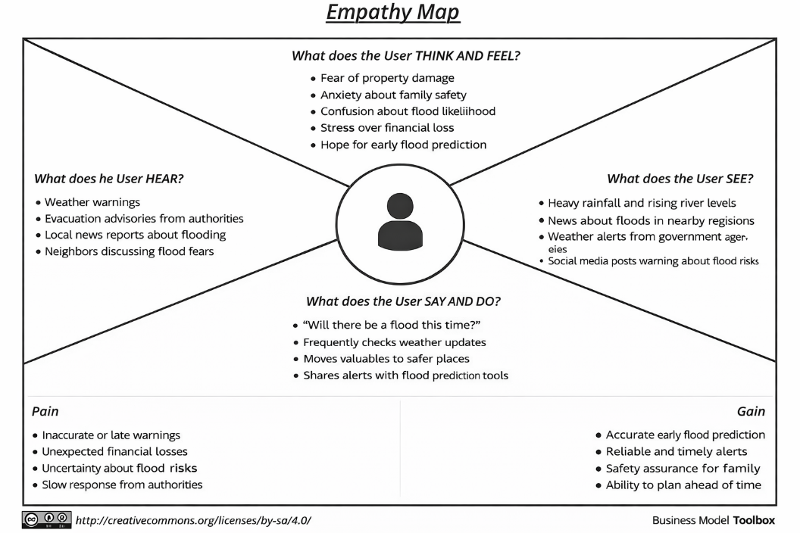

👁️ What Does the User SEE?
- Heavy rainfall in their region
- News about floods in nearby areas
- Rising water levels in rivers
- Weather alerts from government agencies
- Social media posts about flood risks

👂 What Does the User HEAR?
- Weather warnings from meteorological department
- Local authorities advising evacuation
- News channels reporting flood situations
- Neighbors discussing flood fears
- Government SMS alerts

💭 What Does the User THINK & FEEL?
- Fear of property damage
- Anxiety about family safety
- Confusion about whether the flood will actually happen
- Stress about financial loss
- Hope that the situation can be predicted early

🗣️ What Does the User SAY & DO?
- “Will there be a flood this time?”
- Checks rainfall updates frequently
- Shares alerts with family members
- Moves valuables to safer places
- Searches online for flood prediction tools

😟 PAIN (Challenges)
- Lack of accurate early warning
- Financial losses due to unexpected floods
- Poor awareness about flood-prone conditions
- Delayed response from authorities
- Uncertainty about severity level

😊 GAIN (Needs & Expectations)
- Early flood prediction
- Accurate and reliable alerts
- Easy-to-use prediction system
- Safety assurance for family
- Proper planning before disaster

🎯 Problem Statement
People living in flood-prone areas face uncertainty and risk due to unpredictable weather conditions. There is a need for an intelligent system that can analyze rainfall and environmental data to predict the possibility of floods in advance and provide early alerts.

